AI Assisted Coding (Lab Exam)

# Lab Exam(Subgroup-A)

## K.Sindhu meenan(2403A51250)-Batch11

TASK-1:

### A.1 — [S18A1] Compute per-probe average from logs (AI completion)

Your Task:

Write a Python function to parse the raw text (multiple lines) and compute per-probe averages of `ppm`. Return a dict {id: avg} and separately compute an overall average.

Prompt:

Create a Python function that takes a string of CSV-style log lines (id,timestamp,ppm) and returns two things:

1.A dictionary mapping each probe ID to its average ppm and 2.The overall average ppm across all probes (rounded to 2 decimals).

The function should: Handle messy input with extra spaces or malformed rows.

Skip lines that don’t have exactly three fields or contain non-numeric ppm values.

Process the data in a single pass for efficiency.

Example:

Input:

pr181,2025-02-01T08:00,22.5

pr182,2025-02-02T09:00,24.2

pr183,2025-02-03T010:00,25.9

Output:

({'pr181': 22.5, 'pr182': 24.2, 'pr183': 25.9}, 24.2)

Include dictionary accumulation (sum and count per probe), exception handling for Malformed rows, and final average computation.

Code:

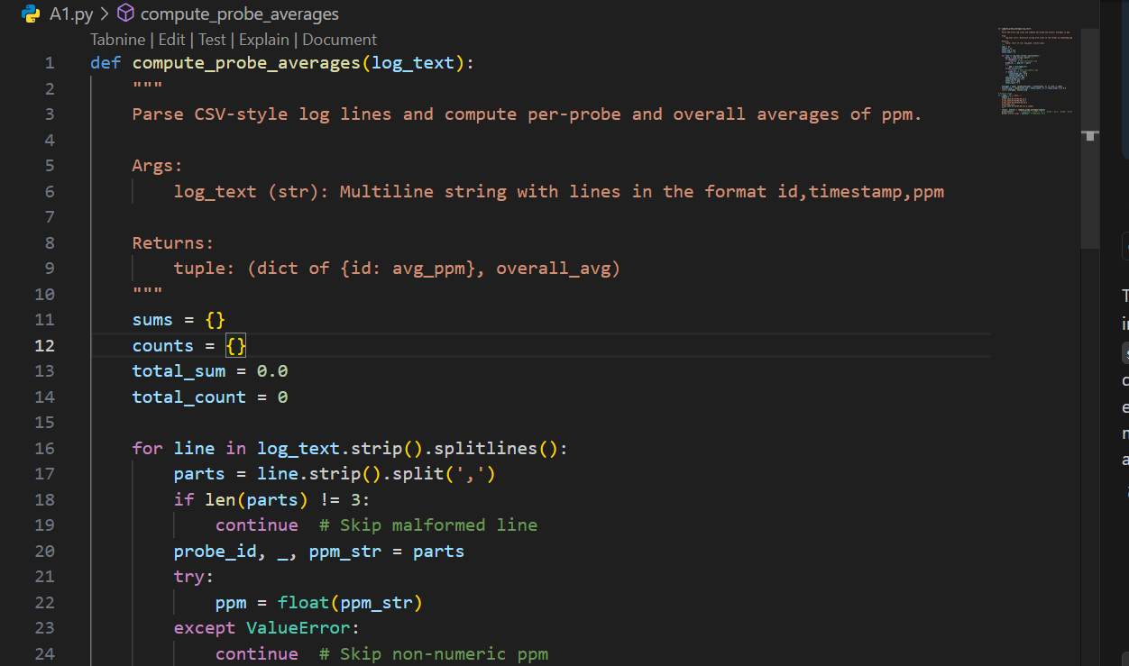

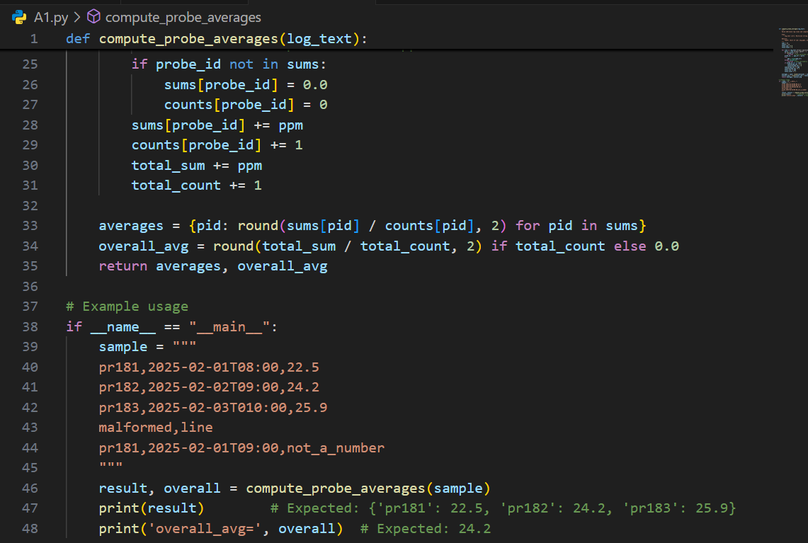

Output:

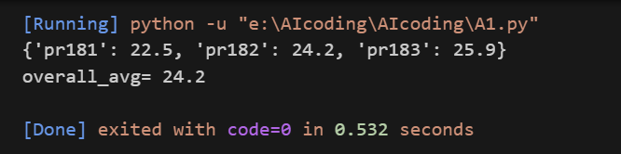

TASK-2:

### A.2 — [S18A2] Implement ListingWindow with add/remove/summary (AI completion)

Prompt:

Create a Python class ListingWindow that tracks numeric values by unique IDs using a dictionary.

It should provide three methods: 1. add(id: str, value: float) insert or update the value for an ID. 2.remove(id: str) safely delete an ID if it exists (ignore if not). 3.summary() tuple[int, float|None] return the number of items and their average value, rounded to 2 decimals. If empty, the average should be None.

The class should: Handle repeated adds by overwriting the value, Avoid errors when removing non-existent IDs, Run all operations in O(1) using a dict.

Sample Input

[{'op': 'add', 'id': 'a1', 'value': 12}, {'op': 'add', 'id': 'b2', 'value': 17}, {'op': 'remove', 'id': 'a1'}, {'op': 'add', 'id': 'c3', 'value': 9}]

Sample Output

count=2, avg=12.5

Acceptance Criteria: Handles add/remove; correct count and average; safe on missing IDs

Code:

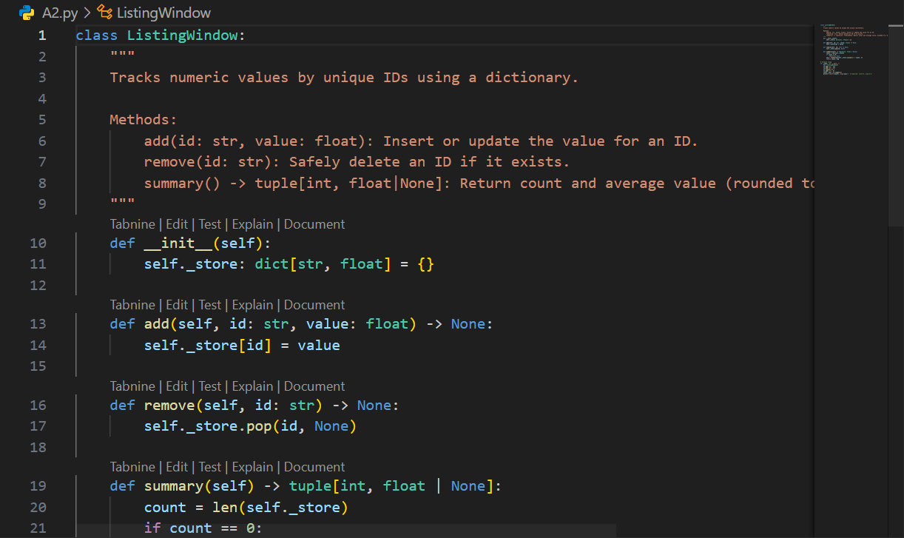

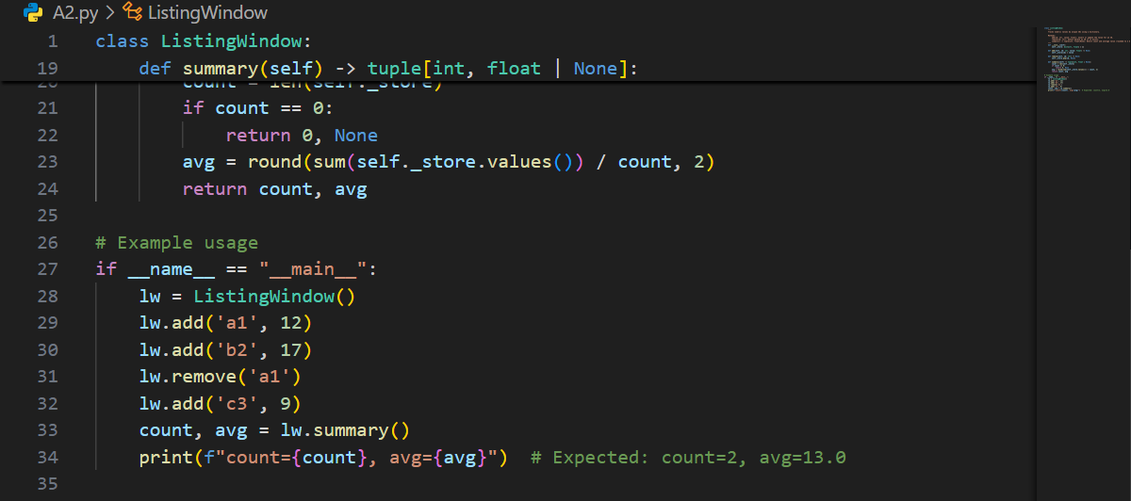

Output:

